# Admin login-

Username-admin

Password-AutoAdmin

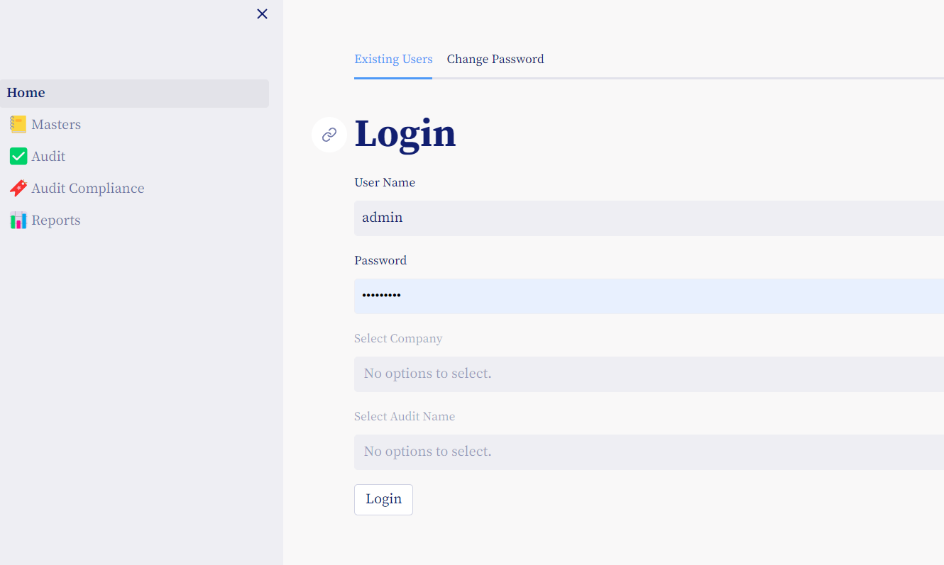

17 tables & Queries

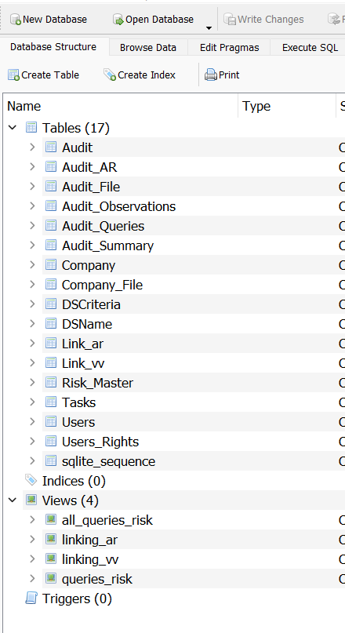

When admin creates new user – Test company & audit both are created

# Step 1-For first time login use following credentials

**User- username as created above**

**Password -Pass123**

**Company -Test**

**Audit- Test**

# Stet2- Create Company

He can now create Company

# Step 3- Create User

Create At least 1 user with User Right – Manager

Create At least 1 user with User Right – Auditor

Create At least 1 user with User Right – Auditee

# Step 4- Assign User Rights for Company

For each Company – 1 person can have Only 1 Role.

# Step 4- Create Audit

User with User Right – Manager -can create Audit

# Database path

Its commented for second options

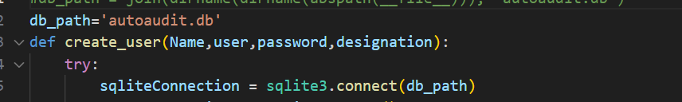

Project path

D:\laptopwork\OneDrive - Acecom Skills Development\laptop work\autoaudit-main\project

Streamlet

<https://acecom123-autoaudit-home-rx6zs1.streamlit.app/>

help file-

<https://acecom22-my.sharepoint.com/:w:/g/personal/saurabhjog_acecomskills_in/ESLKUvAGIMJJontdPiuXk5YBTxjbcYnCkilrcBJ3oHy0ww?rtime=FxwFhqha3Eg>

github

sutoaudit(public )